Write a Program where a gambler starts with Rs 100 and places Re 1 bet

until he/she goes broke i.e. no more money to gamble or reaches the

goal of Rs 200. Keeps track of number of times won and number of bets

made.

#!/bin/bash -x

money=100;

bet=1;

win=0;

loss=0;

count_bet=0;

goal=0;

total=$money;

while [ $money -ge 0 ] && [ $money -le 200 ]

do

money=$(( $money - $bet ))

guess=$(( RANDOM%2 ));

if [ $guess -eq 1 ]

then

win=`expr $win + 1`

count_bet=`expr $count_bet + 1`

money=`expr $money + 1`

else

loss=`expr $loss + 1`

count_bet=`expr $count_bet + 1`

fi

done

echo $win "Number of times won"

echo $loss "Number of times loss"

echo $count_bet "Number of times bet made"

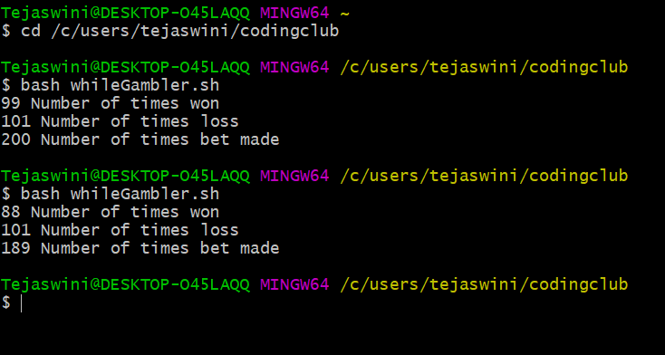

Write a program that takes a command-line argument n and prints a

table of the powers of 2 that are less than or equal to 2^n till 256 is

reached..

#!/bin/bash -x

read -p "Enter a number: " n

limit=$(( 2**n ))

count=0

while [[ $count -lt $limit ]] && [[ $count -lt 256 ]]

do

count=`expr $count + 2`

echo $count;

done